**SPH3U: 2.2 Motion in Two Dimensions – Algebraic Approach**

1. **Adding displacements in two dimensions**

|  |  |
| --- | --- |
| Adding perpendicular vectors: |  |
| magnitude |  |
| angle |  |

A jogger runs 200.0 m [E], turns at an intersection, and continues for an additional displacement of 300.0 m [N]. What is the jogger’s total displacement?

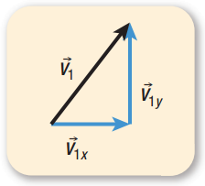

|  |  |
| --- | --- |
| Component vectors: |  |

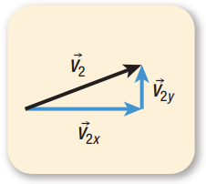Break the displacement vector 30.0 m [E25°N] down into perpendicular component vectors.

A cat walks 20.0 m [W] and then turns and walks a further 10.0 m [S40°E]. What is the cat’s total displacement?

A hockey puck travels a displacement of 4.2 m [S38°W]. It is then struck by a hockey player’s stick and undergoes a displacement of 2.7 m [E25°N]. What is the puck’s total displacement?

1. **Adding velocities in two dimensions**

|  |  |
| --- | --- |
| River crossing problems: |  |

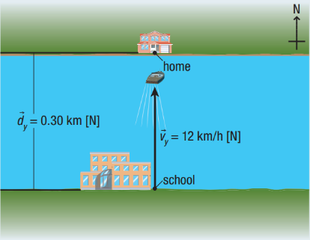A physics student hops into her motorboat and steers straight across a river at a constant velocity of 12 km/h [N]. If the river is 0.30 km across and has no current, how long will it take her to cross the river?

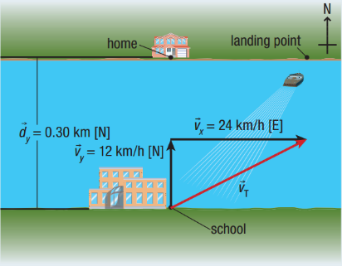

Most rivers have a current moving in the direction of the river. The river now has a current of 24 km/h [E], as shown to the right. How long does it now take the boat to cross the river?

How far downstream does the boat land?

What is the boat’s resultant velocity?

**Homework:** page 75: #1-3, 6b, 8-9